MELOMAKARONA
(Greek Honey Cookies)

One of the designated activities included in our Erasmus+ European program titled “Our Intangible Heritage, a Value for the Future” is the presentation of each country’s traditional celebrations and gastronomy (activity P6). To this end, two of the school’s teachers decided to actually make a Greek traditional Christmas treat in class with a group of students.
Mrs Katerina Giannakoudi and Mrs Eleni Theodoraki, along with some students of the 10th grade, found information about the history of a dessert called ‘melomakarona’, and how it is tied to Christmas celebrations. They then decided to make it in class; they found the recipe, gathered the ingredients and prepared it, using the oven from the school canteen. (They were really delicious, by the way!)
The students showed great enthusiasm for the whole process, since they were actively involved in all stages of preparation. Moreover, they had the chance to learn about the tradition behind this dessert, and to share the spirit of Christmas within their own class!!
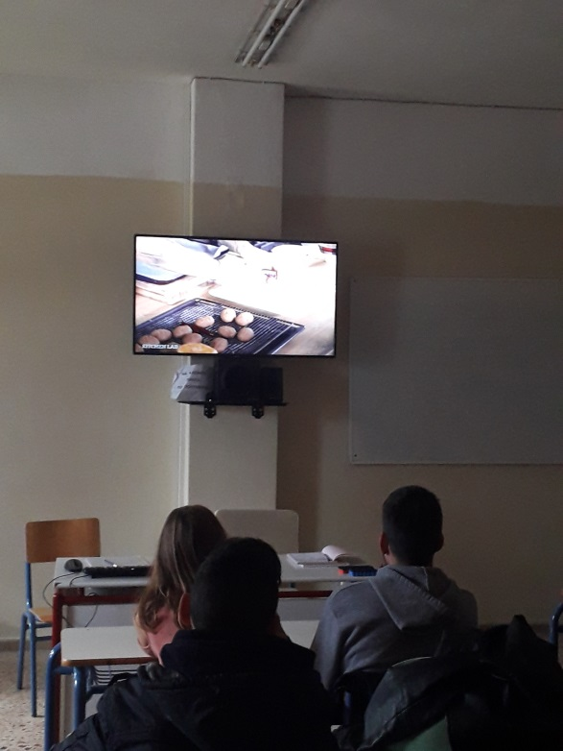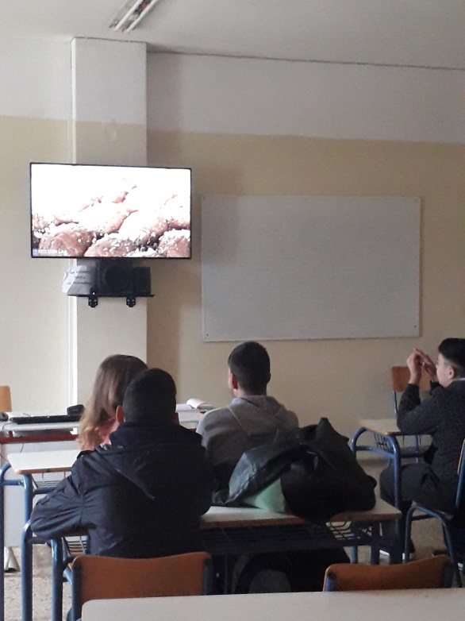

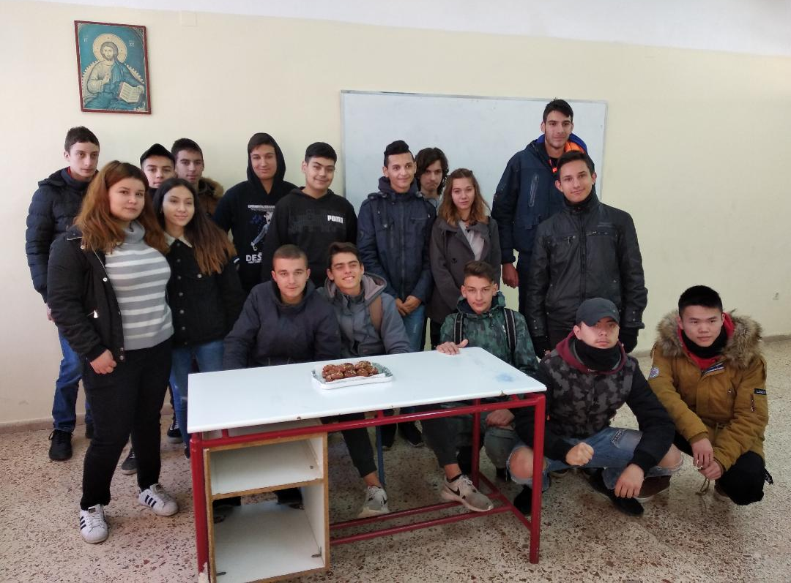

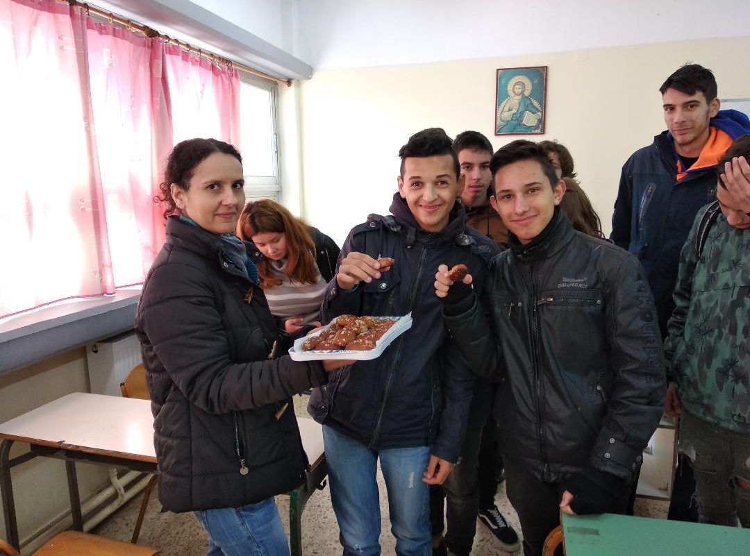

RECIPE
(preparation time: 15 minutes – baking time: 30 minutes – portions: 80)
Step 1: syrup
- 500 gram. water
- 800 gram. sugar
- 150 gram. Honey
- 3 cinnamon sticks
- 3 whole cloves
- 1 orange cut in half
You need to start preparing the syrup 3-4 hours earlier, so that it has enough time to cool down. After it has been boiled, we remove the pan from the stove and add the honey. We stir and let it cool down.

Step 2: melomakarona
Mixture 1:
- 400 gram. orange juice
- 400 gram. sunflower oil 180 gram. olive oil
- 50 gram. caster sugar
- ½ teaspoon clove
- 2-3 teaspoons cinnamon
- ¼ teaspoon nutmeg
- 1 teaspoon baking soda

Mixture 2:
- 1 kilo flour
- 200 gram. semolina

We preheat the oven at 190 C⁰ with airflow. We add all ingredients of mixture 1 into a large bowl and mix them well. In another bowl we add the ingredients of mixture 2. We then mix the two bowls into one and work the mixture by hand for about 10 seconds. We shape the dough into small balls or eggs and bake them for about 20-25 minutes. Once they are ready, we pour the cold syrup over them and leave them for a while. They are usually served with grated walnuts and honey. They can also be covered in chocolate coating.



